CNU-3MT Competition
□ CNU Graduate School Thesis Presentation Competition
1. Competition Name: 2nd CNU-3MT Competition (Organizer: Chonnam National University)
2. Eligibility: Current students of the Chonnam National University Graduate School (including registered students who have completed their coursework)
- Participation Restrictions
ㆍStudents scheduled to graduate in August are ineligible to participate in, as the CNU-3MT Competition is linked to the National Competition (K-3MT, November 2026) and the International Competition (Asia-Pacific 3MT, October 2026).
ㆍGraduate students with exchange student status.
ㆍGraduate students participating in similar programs with the same content.
3. Language: English only
4. Presentation Format and Eligible Theses
◦ Presentation Format: Summarize your thesis in 3 minutes or less and present using a single slide
◦ Eligible Theses (Theses only)
- Current Master’s students: Master’s thesis currently in progress.
- Current doctoral students: Master’s thesis or doctoral dissertation currently in progress.
5. Competition Structure: Preliminary Round + Final Round
◦ Preliminary Round: A designated committee will evaluate the submitted presentation videos and slides to select finalists.
◦ Final Round: On-site evaluation through public presentation (Specific details, including venue, will be provided separately)
- Date and Time (Tentative): Tuesday, August 25, 2026, at 10:00 a.m.
- Judging Panel (Tentative): Comprised of up to 5 members
6. Rules and Evaluation Criteria (Preliminary & Final Round)
- Present a summary of the participants’ own thesis in 3 minutes or less
- Only one single slide is permitted
- Presentation must be concise, clear and accessible to a non-expert audience
7. Presentation Training for Finalists
- Date and Time (Tentative): Thursday, August 20, 2026, at 5:00 PM (Subject to change depending on the availability of the participants and instructors)
8. Competition Procedures
9. Detailed Evaluation Criteria for the Final Round
- Evaluated on whether the presentation provideds a clear rationale, background, and significance of the research question
Evaluation Categories | Points | Detailed Evaluation Criteria
Slides | 40 | ·Can the audience follow the research’s problem, core, contribution, and impact from a single slide?  ·Are the slides clearly organized and do they effectively complement the presentation?  ·Is the information prioritized appropriately, and does the visual flow feel natural?  ·Is the text concise and focused on keywords?
Presentation | 60 | ·Did the presentation provide a clear motivation, background, and significance for the research question?  ·Did the presentation clearly explain the research strategy/design and the research results/findings?  ·Did the presentation clearly explain the study’s conclusions, achievements, and impact?  ·Was the content conveyed clearly, and was language appropriate for a non-expert audience?  ·Did the presenter convey enthusiasm for the research and capture and maintain the audience’s attention?
Total | 100
10. Registration and Required Materials
◦ Submission Method: Via email (coolevil@nate.com)
◦ Submission Period: July 28 (Tue), 10:00 AM - August 6 (Tue), 11:00 AM, 2026
◦ Required Materials for Registration

Category | Production Guidelines  (Filming, etc.) | Target Applicants
1. Application Form (Form 1) | Complete the attached application form, sign and stamp it, then scan and submit it as a PDF or image file. | All applicants
2. Presentation Video | · Film in landscape orientation.  · Use a solid-color background.  · Keep the camera or smartphone fixed in place (use a tripod).  ·Record from the waist up (upper body), ensuring the entire head is visible.  ·No video editing is allowed other than inserting slide. Cutting and splicing (editing out parts) is prohibited; the video must be a single-take recording. Do not use subtitles, CGI, or a background music.  ·The presentation must be spoken only. No poems, songs, etc., are not allowed.  · No props or additional materials allowed  (e.g., laboratory equipment, placards, costumes, musical instruments, etc.).  · Use of third-party copyrighted materials without permission will result in disqualification.  · Content inappropriate for public or social media disclosure is prohibited. | All Applicants
3. 1-Page Slide  (See example below) | Summarize research content on a single-page slide; no effects (animations and etc.) allowed; 16:9 aspect ratio; No title sled allowed. | All Applicants
4. Academic Advisor's Confirmation of Thesis Supervision  (Select and complete either Form 3 or 3-1) | - Complete the attached form, Sign and stamp, then scan, and submit as a PDF or image file.  · Required to provide that the presentation is based on the thesis/dissertation currently being prepared by Master’s and Doctoral students.  ※ Doctoral students presenting their Master’s thesis are exempt from this requirement. | All Applicants
5. Academic Advisor's Confirmation of Thesis Research Proposal  (Select and complete either Form 4 or 4-1) | Only for those selected as representatives of our university for the Asia-Pacific 3MT Competition (separate instruction will be provided) | Selected candidates only
6. Consent  (Select and complete either Form 2 or 2-1) | Complete the attached consent form, sign and stamp, then scan and submit as a PDF or image file | All applicants
※ If any discrepancy is found between the winner’s actual thesis and the information provided in the confirmation form, the award may be revoked and the prize money may be reclaimed.

Example of a presentation video
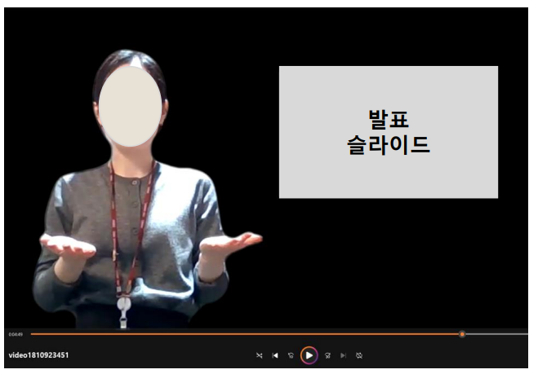 | 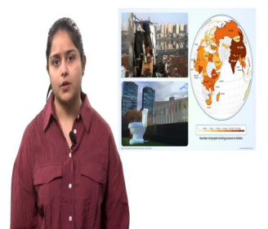
Example of a presentation video | Still Image from the 2025 Asia-Pacific Championship winner’s video

Example of a 1-page slide
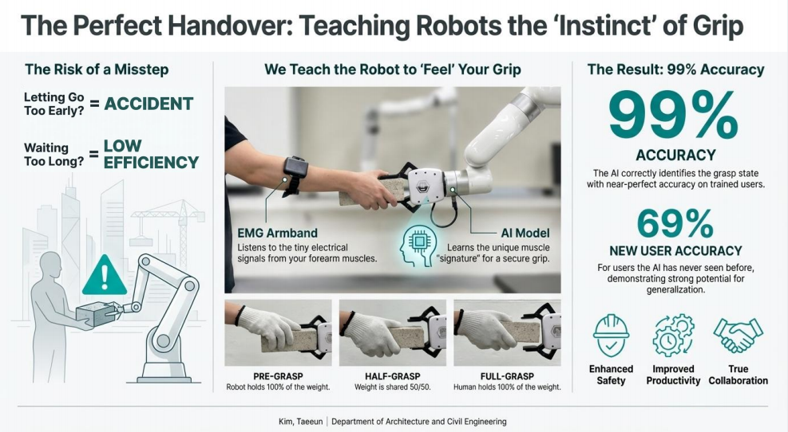 | 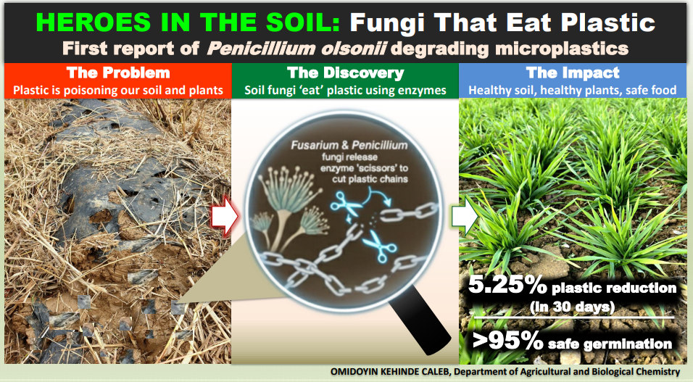
Slides of the 2025 CNU 1ST Competition -President's Award Winner’s Slide | Slides of the 2025 CNU 1ST Competition-Excellence Award Winner’s Slide

11. Award Plan
Category | Prize Money | Number of Recipients
President’s Award | 2,000,000 KRW | 1
Graduate School Dean’s Award—Outstanding Award | 1,500,00 KRW | 1
Graduate School Dean’s Award— Excellence Award | 1,000,000 KRW | 3
Graduate School Dean’s Award— Encouragement Award | 500,000 KRW | 5
12. Detailed Implementation Schedule
Timeline | Activity
July 22, 2026 (Wed) | Contest Announcement
10am, July 28, 2026 (Tue) – 11am, August 6, 2026 (Thu) | Application Period
August 10, 2026 (Mon) – August 14, 2026 (Fri) | Preliminary Screening
August 18, 2026 (Tue) | Announcement of Finalists
August 20, 2026 (Thu) | Presentation Coaching for Finalists
August 25, 2026 (Tue), 10:00 a.m. | CNU-3MT Finals and Award Ceremony
※ The detailed schedule is subject to change depending on the academic calendar and the number of participants.

National Competition (K-3MT)
A. Competition Name: K-3MT (Organizer: Korea University)
B. Competition Format
◦ Graduate students summarize their own thesis and present in 3 minutes or less
◦ Only one single slide is permitted
◦ Presentation must be concise, clear and accessible to a non-expert audience
C. Presentation Method and Eligible Theses
◦ Presentation Format: Summarize your own thesis in 3 minutes or less and present using a single slide
◦ Eligible Theses (Theses only)
- Current Master’s students: Master’s thesis currently in progress
- Current Ph.D. students: Master’s thesis or Ph.D. thesis currently in progress
D. Selection of University Representatives (3) and Training Support
◦ The top 1–3 finishers in the CNU-3MT Competition finals will be selected as representatives
※ If a top-ranked participant is unable to participate due to ineligibility or other reasons, the next-ranked participant will be selected
◦ Separate 1:1 tutoring will be provided to representatives (conducted in-house)
◦ Details regarding the submission for the next stage will be provided separately to the selected representatives
E. Required Submission Materials
◦ Presentation script, one slide, and presentation video
※ The Graduate School will provide support for video production, etc.

F. Important Notice (Based on Korea University Guidelines)
◦ Unauthorized use of third-party copyrighted materials will result in disqualification
◦ Consent for the public use of submitted materials is mandatory
◦ Finalists must attend the final round → The top six award winners are required to attend the Graduate School Innovation Achievement Forum
G. Awards (Tentative)
- Minister of Education Award (1), National Research Foundation of Korea President’s Award (2), Graduate School Innovation Council Chairperson’s Award (3)
H. Detailed Schedule
Timeline | Activity | Remarks
Aug. 27, 2026 (Thu) – Sept. 4, 2026 (Fri) | 1:1 Tutoring for 3 CNU representatives
Sept. 5, 2026 (Sat) – Sept. 10, 2026 (Thu) | Production of Final Round videos and slides | Supported by the Graduate school support
September 11, 2026 (Fri) | K-3MT Video Submission Deadline
September 12, 2026 (Sat) – September 30, 2026 (Wed) | Screening by the host university | 63 participants total
Early October 2026 | Announcement of finalists | 20–25 finalists selected
October 17, 2026 (Sat) | Presentation Coaching Session 1  (at Korea University)
October 21, 2026 (Wed) | Presentation Coaching Session 2  (at Korea University)
November 11, 2026 (Wed) | K-3MT Grand Final
※ The schedule is subject to change; Any updates will be notified individually to the selected university representatives.
International Competition (Asia-Pacific 3MT)
A. Competition Name: Asia-Pacific 3MT (Organizer: The University of Queensland)
B. Competition Format
◦ Graduate students summarize their own thesis and present in 3 minutes or less
◦ Only one single slide is permitted
◦ Presentation must be concise, clear and accessible to a non-expert audience
C. Competition Mode: Virtual Competition (Conducted entirely online)
D. Eligibility
◦ Doctoral candidates (including those who have completed coursework and registered) who have passed their thesis proposal and comprehensive exam by the presentation date (scheduled for September 21, 2026).
※ Ineligible: Graduates, Master’s students, and integrated master’s-Ph.D. student who have completed fewer than 3 semesters and earned fewer than 24 credits
E. Awards: First Place (5,000 AUD), Second Place (2,000 AUD), People’s Choice Award (1,000 AUD)
F. Selection & Support for University Representative (1 Person)
◦ The Winner of the CNU-3MT Competition will be selected as the university representative
※ If the top-ranked candidate is ineligible to participate (e.g., due to failing to meet eligibility requirements), the next-highest-ranked eligible candidate will be selected
◦ 1:1 Tutoring & Coaching will be provided to the representative (conducted in-house)
◦ Further details on material submission will be provided individually to the representative

G. Competition Procedures
1. Each university selects one representative.
2. Registration: Friday, September 11, 2026 (online application)
3. Announcement of semifinalists: Monday, September 21, 2026
4. Announcement of finalists: Friday, October 2, 2026
5. Announcement of winners: Wednesday, October 14, 2026

서식 1 CNU-3MT 참가 신청서
CNU-3MT Competition 참가 신청서
[CNU 3 Minute Thesis Competition]
성명  Name |  | 학과/전공  Department/Major
학번  Student Number |  | 연락처  Contact Info. |  |  | 이메일(Email):  모바일(Mobile):
학위과정  Program | □ 석사 MA, MS Degree |  | □ 박사 Doctorate (Ph.D.) |  |  | □ 석박통합과정  MS-Ph.D. Integrated
학위과정  Program | 지도교수:  Academic Advisor:
BK21 참여대학원생  4th BK21 Participating Graduate Students | □ 참여(지원)  Funded BK21 Participant |  |  | □ 참여(미지원)  Not-funded BK 21 participant |  |  | □ 해당사항 없음  N/A
BK21 참여대학원생  4th BK21 Participating Graduate Students | 소속 BK21 교육연구단(팀)명:  Name of BK21 Project Division(Team):
학위논문 제목  Thesis Title | 학위논문의 제목을 적으시오.  please write your thesis title.
발표 주제  Presentation Topic | 3분 발표에 사용할 주제의 제목을 적으시오.  Write the title of your 3-minute presentation.
발표내용 요약  500단어 내외로 작성  Presentation Content Summary  (Summarize in about 300 English words, equivalent to 500 words in Korean) | 3분 발표에 사용할 논문의 주요 내용을 적으시오.  [※가능한 구두 발표의 원고 (script) 형식으로 작성해 주세요]  Please outline the key points of your 3-minute presentation.  [※If possible, provide them in the form of a script for an oral presentation]
별도 첨부된 CNU-3MT Competition 정보를 숙지하였으며,
적극적으로 참여하고자 다음과 같이 신청서를 제출합니다.
I have reviewed the separately attached CNU-3MT Competition Information,
and hereby submit this application form to confirm my participation.

2026년 월 일
(Year). (Month). (Date).

참가자 성명(Participant Name): (서명, Signature)
전남대학교 대학원혁신본부 귀하

서식 2-1 Consent Form
Consent Form for the Collection and Use of Personal Information
and Use of Recordings
[Consent to the Collection and Use of Personal Information]

I hereby consent to the collection and use of my personal information in relation to my participation in the CNU-3MT Competition organized by the Office of Graduate School at Chonnam National University.

1. Items Collected: Name, department(major), student number, contact information (email and phone number), degree program, academic advisor’s name, etc.
2. Purpose of Collection: Program operation, participant verification and evaluation, notification of results, and post-program management.
3. Retention Period: five (5) years from the date of collection.
4. Provision to Third Parties: None.

※ You have right to refuse this consent. However, please note that refusal may restrict your participation in the program.

[Consent and Agreement for the Use of Recorded Videos and Images]

I hereby agree that the presentation videos, images, and related personal information (name, department, etc.) recorded during my participation in the CNU-3MT Competition may be used by the Office of Graduate School for promotional purposes, as outlined below.

1. Scope of Use:
- Recording, editing, and storing of presentation videos and images
- Use for promotional purposes (e.g., publication on websites, YouTube, press releases, bulletin boards, etc.)
2. Media Platforms:
- Chonnam National University website, YouTube, social media, press materials, promotional posters, brochures, etc.
3. Usage Period: Until the fulfillment of the intended purpose.

※ You have right to refuse this consent. However, please note that refusal may restrict your participation in the program.

I have read and understood the information provided above and hereby agree to the collection, use of my personal information, as well as the use of my presentation materials for promotional.

Date: (Year) (Month) (Day)
Name: (Signature)
대학원혁신본부 귀하

서식 3-1 Academic Advisor's Confirmation of Thesis Supervision
CNU-3MT Competition
Academic Advisor's Confirmation of Thesis Supervision
Name |  | Department/Major
Student Number |  | Contact Info. |  | Email:  Mobile:
Program | □ MA, MS Degree |  | □ Doctorate (Ph.D.) |  | □ MS-Ph.D. Integrated
Program | Academic Advisor:
Thesis title | please write your thesis title.
Thesis Abstract | Please outline the key points of your thesis.  (Summarize the content of your thesis in 3–5 sentences.)
I hereby confirm that the above information is true and correct,
and I aaply to participate in the CNU-3MT Competition with this research.

Date: (Year) (Month) (Day)

Participant's Name: (Signature)
Academic Advisor's Name: (Signature)
To: Graduate School Innovation Headquarters,
Chonnam National University

서식 4-1 Academic Advisor's Confirmation of Thesis Research Proposal
CNU-3MT Competition
Academic Advisor's Confirmation of Thesis Research Proposal
Name |  | Department/Major
Student Number |  | Contact Info. |  | Email:  Mobile:
Program | □ MA, MS Degree |  | □ Doctorate (Ph.D.) |  | □ MS-Ph.D. Integrated
Program | Supervisor:
Thesis Title | Please write your title of thesis in English
Research Purpose | Example: This study aims to derive OOO by using the OOO methodology to elucidate OOO.
Research Methods | Example: This study plans to perform OOO analysis using OOO data/literature.
In lieu of a formal thesis research proposal defence,
I have presented and reviewed the aforementioned research plan with my academic advisor.

Date: (Year) (Month) (Day)
Participant's Name: (Signature)

I certify that the applicant's thesis research proposal meets
the academic standards of the Graduate School,
accordingly, provide my official approval.

Date: (Year) (Month) (Day)
Academic Advisor's Name: (Signature)

전남대학교 대학원혁신본부 귀하

